Table 1: Vertical excitation energies and dominant contributions of the S₀ and S₁ states of fulvene optimized with SA2-CASSCF(6,6)/6-31G* and MRCI(CAS(6,6))/6-31G*. For MRCI, the Pople correction is also given (MRCI/+Pople).
State | ∆E (eV) | Configuration | %
SA2-CASSCF(6,6) – S₀ optimization
S₀ | 0.000 | (19a)²(20a)²(21a)²(22a)⁰(23a)⁰(24a)⁰ | 77.3
S₁ | 4.110 | (19a)²(20a)²(21a)¹(22a)¹(23a)⁰(24a)⁰ | 74.0
 |  | (19a)²(20a)¹(21a)¹(22a)²(23a)⁰(24a)⁰ | 14.1
SA2-CASSCF(6,6) – S₁ optimization
S₀ | 1.446 | (19a)²(20a)²(21a)²(22a)⁰(23a)⁰(24a)⁰ | 66.5
 |  | (19a)²(20a)¹(21a)²(22a)¹(23a)⁰(24a)⁰ | 13.8
S₁ | 2.611 | (19a)²(20a)²(21a)¹(22a)¹(23a)⁰(24a)⁰ | 72.3
 |  | (19a)²(20a)¹(21a)¹(22a)²(23a)⁰(24a)⁰ | 15.8
SA2-CASSCF(6,6) – MXS optimization - Planar
S₀ | 2.880 | (19a)²(20a)²(21a)¹(22a)¹(23a)⁰(24a)⁰ | 73.0
 |  | (19a)²(20a)¹(21a)¹(22a)²(23a)⁰(24a)⁰ | 15.4
S₁ | 2.880 | (19a)²(20a)²(21a)²(22a)⁰(23a)⁰(24a)⁰ | 60.1
 |  | (19a)²(20a)¹(21a)²(22a)¹(23a)⁰(24a)⁰ | 16.8
SA2-CASSCF(6,6) – MXS optimization – nonplanar (fixed 20°)
S₀ | 2.796 | (19a)²(20a)²(21a)²(22a)⁰(23a)⁰(24a)⁰ | 59.8
 |  | (19a)²(20a)¹(21a)²(22a)¹(23a)⁰(24a)⁰ | 17.2
S₁ | 2.796 | (19a)²(20a)²(21a)¹(22a)¹(23a)⁰(24a)⁰ | 72.9
 |  | (19a)²(20a)¹(21a)¹(22a)²(23a)⁰(24a)⁰ | 15.4
SA2-CASSCF(6,6) – MXS optimization – nonplanar (fixed 45°)
S₀ | 2.549 | (19a)²(20a)²(21a)²(22a)⁰(23a)⁰(24a)⁰ | 51.1
 |  | (19a)²(20a)¹(21a)²(22a)¹(23a)⁰(24a)⁰ | 17.4
S₁ | 2.549 | (19a)²(20a)²(21a)¹(22a)¹(23a)⁰(24a)⁰ | 64.7
 |  | (19a)²(20a)¹(21a)¹(22a)²(23a)⁰(24a)⁰ | 13.6
SA2-CASSCF(6,6) – MXS optimization – nonplanar (63°)
S₀ | 2.445 | (19a)²(20a)²(21a)¹(22a)¹(23a)⁰(24a)⁰ | 73.4
 |  | (19a)²(20a)¹(21a)¹(22a)²(23a)⁰(24a)⁰ | 13.5
S₁ | 2.456 | (19a)²(20a)²(21a)²(22a)⁰(23a)⁰(24a)⁰ | 48.1
 |  | (19a)²(20a)¹(21a)²(22a)¹(23a)⁰(24a)⁰ | 28.3
SA2-CASSCF(6,6) – MXS optimization – nonplanar (fixed 70°)
S₀ | 2.470 | (19a)²(20a)²(21a)¹(22a)¹(23a)⁰(24a)⁰ | 79.7
S₁ | 2.470 | (19a)²(20a)¹(21a)²(22a)¹(23a)⁰(24a)⁰ | 47.0
 |  | (19a)²(20a)²(21a)²(22a)⁰(23a)⁰(24a)⁰ | 28.3
SA2-CASSCF(6,6) – MXS optimization – nonplanar (fixed 90°)
S₀ | 2.553 | (19a)²(20a)²(21a)¹(22a)¹(23a)⁰(24a)⁰ | 87.8
S₁ | 2.553 | (19a)²(20a)²(21a)¹(22a)¹(23a)⁰(24a)⁰ | 85.5
MRCI – S₀ optimization
S₀ | 0.000/0.000 | (19a)²(20a)²(21a)²(22a)⁰(23a)⁰(24a)⁰ | 69.1
S₁ | 3.841/3.633 | (19a)²(20a)²(21a)¹(22a)¹(23a)⁰(24a)⁰ | 71.1
MRCI – S₁ optimization
S₀ | 1.235/1.152 | (19a)²(20a)²(21a)²(22a)⁰(23a)⁰(24a)⁰ | 62.3
S₁ | 2.609/2.459 | (19a)²(20a)²(21a)¹(22a)¹(23a)⁰(24a)⁰ | 67.8
 |  | (19a)²(20a)¹(21a)¹(22a)²(23a)⁰(24a)⁰ | 10.1
MRCI – MXS optimization - Planar
S₀ | 3.022/2.972 | (19a)²(20a)²(21a)¹(22a)¹(23a)⁰(24a)⁰ | 62.8
S₁ | 3.022/2.860 | (19a)²(20a)²(21a)²(22a)⁰(23a)⁰(24a)⁰ | 52.8
 |  | (19a)²(20a)¹(21a)²(22a)¹(23a)⁰(24a)⁰ | 11.9
MRCI – MXS optimization – Nonplanar (fixed 20°)
S₀ | 2.930/2.891 | (19a)²(20a)²(21a)¹(22a)¹(23a)⁰(24a)⁰ | 65.9
 |  | (19a)²(20a)¹(21a)¹(22a)²(23a)⁰(24a)⁰ | 10.4
S₁ | 2.930/2.769 | (19a)²(20a)²(21a)²(22a)⁰(23a)⁰(24a)⁰ | 55.4
 |  | (19a)²(20a)¹(21a)²(22a)¹(23a)⁰(24a)⁰ | 12.8
MRCI – MXS optimization – Nonplanar (fixed 45°)
S₀ | 2.649/2.584 | (19a)²(20a)²(21a)¹(22a)¹(23a)⁰(24a)⁰ | 40.4
 |  | (19a)²(20a)²(21a)²(22a)⁰(23a)⁰(24a)⁰ | 21.3
S₁ | 2.649/2.559 | (19a)²(20a)²(21a)²(22a)⁰(23a)⁰(24a)⁰ | 33.0
 |  | (19a)²(20a)²(21a)¹(22a)¹(23a)⁰(24a)⁰ | 26.1
MRCI – MXS optimization – nonplanar (65.1°)
S₀ | 2.519/2.521 | (19a)²(20a)²(21a)¹(22a)¹(23a)⁰(24a)⁰ | 66.9
S₁ | 2.519/2.423 | (19a)²(20a)²(21a)²(22a)⁰(23a)⁰(24a)⁰ | 45.1
 |  | (19a)²(20a)¹(21a)²(22a)¹(23a)⁰(24a)⁰ | 23.7
MRCI – MXS optimization – Nonplanar (fixed 70°)
S₀ | 2.527/2.446 | (19a)²(20a)²(21a)²(22a)⁰(23a)⁰(24a)⁰ | 39.3
 |  | (19a)²(20a)¹(21a)²(22a)¹(23a)⁰(24a)⁰ | 29.2
S₁ | 2.527/2.534 | (19a)²(20a)²(21a)¹(22a)¹(23a)⁰(24a)⁰ | 67.7
MRCI – MXS optimization – Nonplanar (fixed 90°)
S₀ | 2.618/2.628 | (19a)²(20a)²(21a)¹(22a)¹(23a)⁰(24a)⁰ | 63.2
 |  | (19a)²(20a)¹(21a)²(22a)¹(23a)⁰(24a)⁰ | 13.0
S₁ | 2.618/2.595 | (19a)²(20a)¹(21a)²(22a)¹(23a)⁰(24a)⁰ | 62.9
 |  | (19a)²(20a)²(21a)¹(22a)¹(23a)⁰(24a)⁰ | 13.1

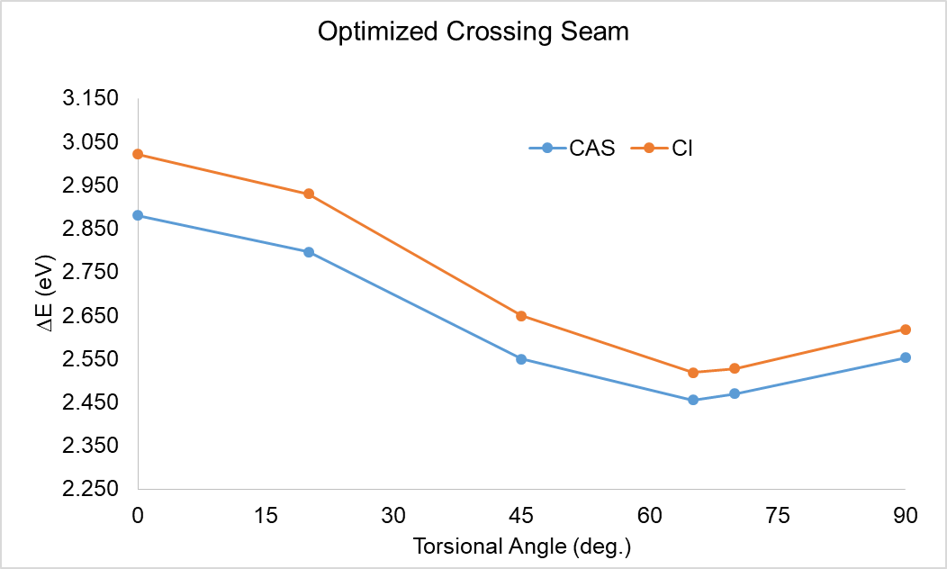
Figure 1: Relative energy of the optimized crossing seam between the S₀ and S₁ states using the SA2-CASSCF(6,6)/6-31G* and MRCI(CAS(6,6))/6-31G* methods. Energies relative to the optimized S₀ ground state in each method.

Table 2: Total energies in Hartree of fulvene
 | S₀ | S₁
SA2-CASSCF(6,6)-S₀ opt | -230.72231 | -230.57127
SA2-CASSCF(6,6)-S₁ opt | -230.66916 | -230.62635
SA2-CASSCF(6,6)-MXS-planar | -230.61647 | -230.61647
SA2-CASSCF(6,6)-MXS-nonplanar (20°) | -230.61957 | -230.61955
SA2-CASSCF(6,6)-MXS-nonplanar (45°) | -230.62862 | -230.62862
SA2-CASSCF(6,6)-MXS-nonplanar (63°) | -230.63208 | -230.63206
SA2-CASSCF(6,6)-MXS-nonplanar (70°) | -230.63154 | -230.63154
SA2-CASSCF(6,6)-MXS-nonplanar (90°) | -230.62850 | -230.62850
MRCI-S₀ opt | -231.33320 | -231.19206
MRCI+Q-S₀ opt | -231.46471 | -231.33121
MRCI-S₁ opt | -231.28780 | -231.23732
MRCI+Q-S₁ opt | -231.42239 | -231.37102
MRCI-MXS-planar | -231.22216 | -231.22216
MRCI+Q-MXS-planar | -231.35550 | -231.35960
MRCI-MXS-nonplanar (20°) | -231.22553 | -231.22553
MRCI+Q-MXS-nonplanar (20°) | -231.35848 | -231.36297
MRCI-MXS-nonplanar (45°) | -231.23585 | -231.23585
MRCI+Q-MXS-nonplanar (45°) | -231.36976 | -231.37068
MRCI-MXS-nonplanar (65.1°) | -231.24064 | -231.24064
MRCI+Q-MXS-nonplanar (65.1°) | -231.37206 | -231.37566
MRCI-MXS-nonplanar (70°) | -231.24033 | -231.24033
MRCI+Q-MXS-nonplanar (70°) | -231.37480 | -231.37157
MRCI-MXS-nonplanar (90°) | -231.23698 | -231.23698
MRCI+Q-MXS-nonplanar (90°) | -231.36814 | -231.36934

Table 3: Oscillator strength of the S₀ to S₁ transition of fulvene optimized with SA2-CASSCF(6,6)/6-31G* and MRCI(CAS(6,6))/6-31G*.
Method | f
SA2-CASSCF(6,6) – S₀ optimization | 0.00
SA2-CASSCF(6,6) – S₁ optimization | 0.00
MRCI – S₀ optimization | 0.01
MRCI – S₁ optimization | 0.00

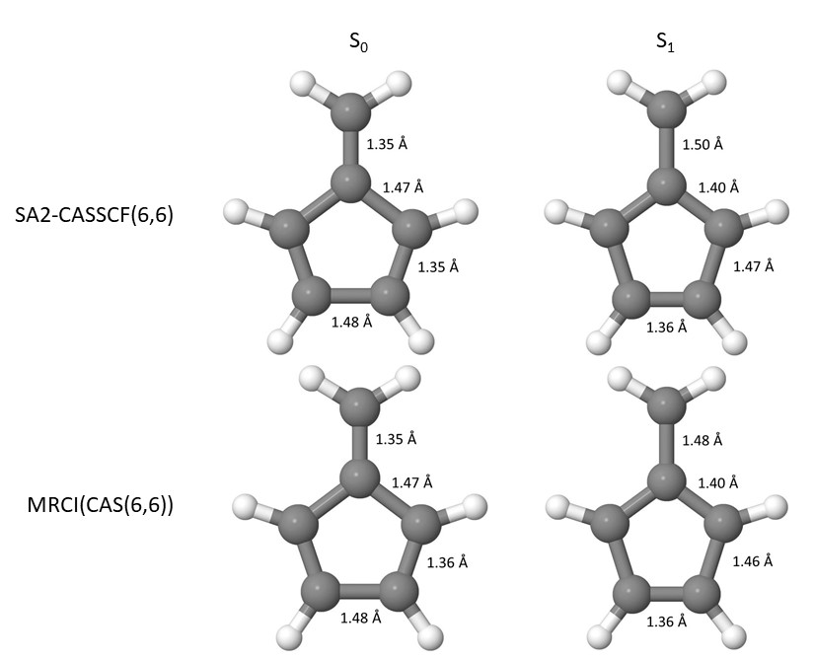
Figure 2: Bond distances of the S₀ to S₁ states optimized with SA2-CASSCF(6,6)/6-31G* and MRCI(CAS(6,6))/6-31G*.

Figure 3: Torsional angles of the S₀ to S₁ states optimized with SA2-CASSCF(6,6)/6-31G* and MRCI(CAS(6,6))/6-31G*. The molecule is planar, so there is no variation. Torsional angles, blue and red, are designated with colored dots.

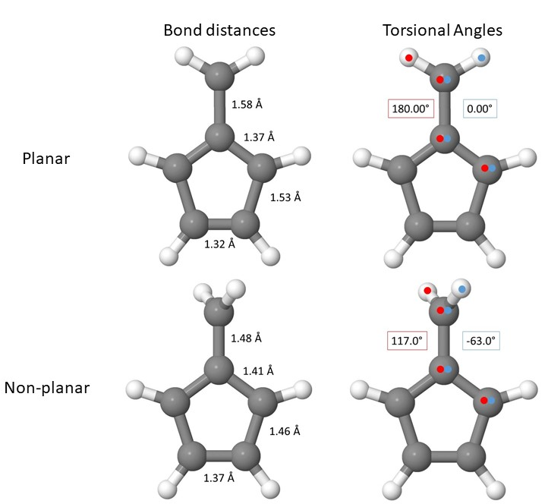
Figure 4: Bond distances and torsional angles of the optimized crossing seam between the S₀ to S₁ states optimized with SA2-CASSCF(6,6)/6-31G*. Torsional angles, blue and red, are designated with colored dots.

Table 4: C-C bond distances for each fixed torsional angle about the CH2 group using the SA2-CASSCF(6,6)/6-31G* and MRCI(CAS(6,6))/6-31G* methods.
Torsional Angle | C-C_{a} | C-C_{b} | C-C_{c} | C-C_{d}
 | SA2-CASSCF(6,6)
20.0° | 1.56 | 1.37 | 1.52 | 1.32
45.0° | 1.51 | 1.39 | 1.49 | 1.34
63.0° | 1.48 | 1.41 | 1.46 | 1.37
70.0° | 1.47 | 1.41 | 1.44 | 1.38
90.0° | 1.48 | 1.42 | 1.42 | 1.41
 | MRCI
20.0° | 1.56 | 1.37 | 1.53 | 1.32
45.0° | 1.51 | 1.38 | 1.50 | 1.33
65.1° | 1.47 | 1.40 | 1.46 | 1.37
70.0° | 1.47 | 1.41 | 1.45 | 1.38
90.0° | 1.47 | 1.42 | 1.42 | 1.41

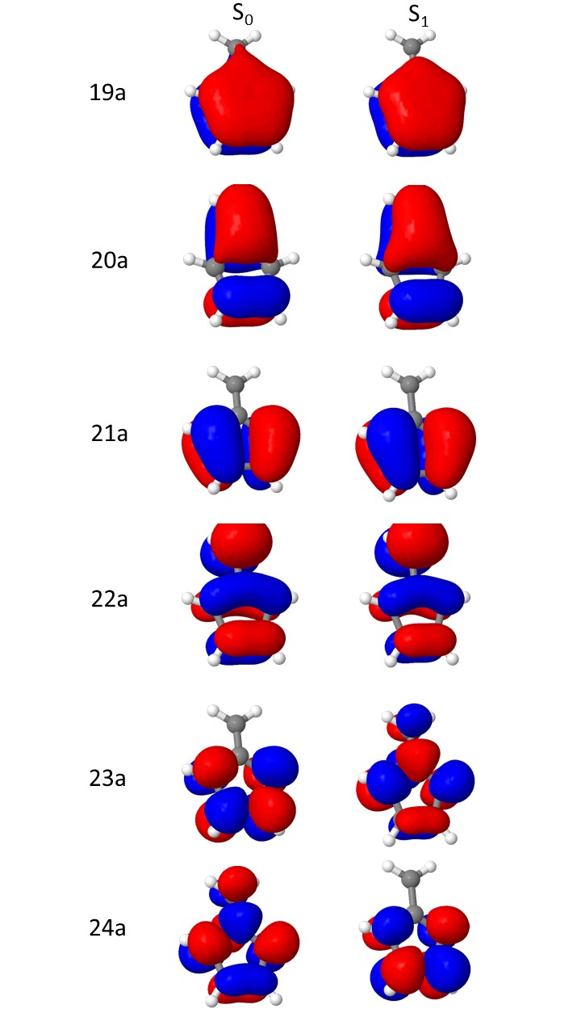
Figure 5: Optimized active orbitals for the S₀ and S₁ states, respectively, optimized with SA2-CASSCF(6,6)/6-31G*.

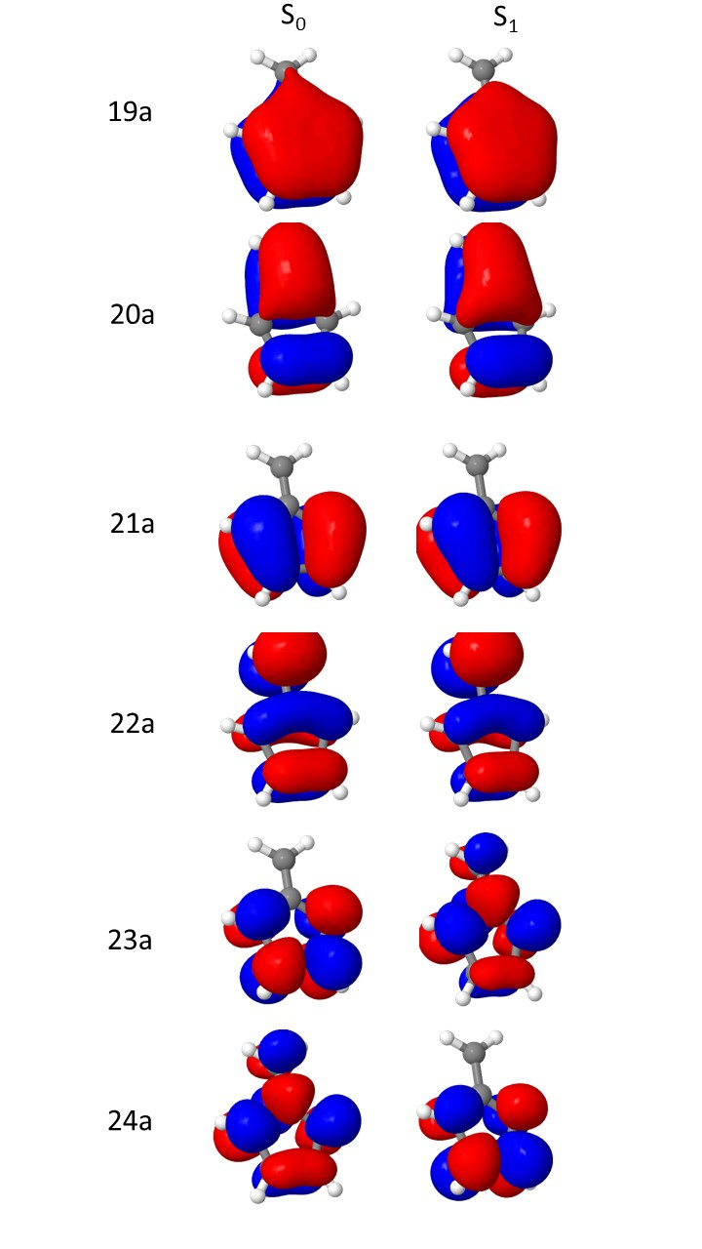
Figure 6: Optimized active orbitals for the S₀ and S₁ states, respectively, optimized with MRCI(CAS(6,6))/6-31G*.

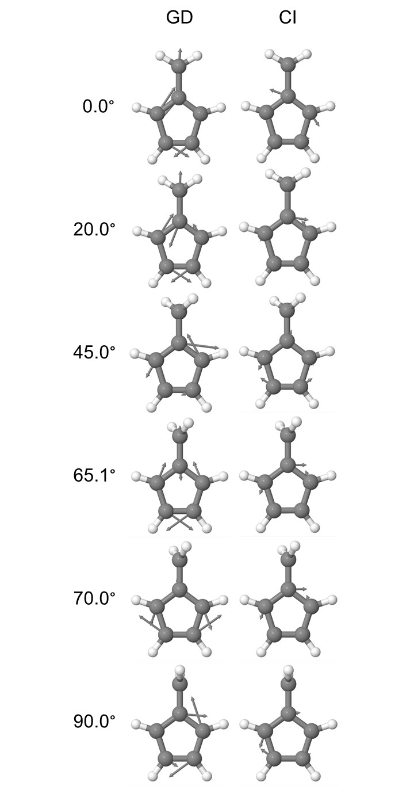
Figure 7: Plots of the GD and CI vectors of fulvene at the optimized crossing seam for several torsional angles going to the -CH₂ group. The MRCI(CAS(6,6))/6-31G* was utilized. The lowest energy structure at the crossing seam corresponds to 65.1°.

