Table 1: Vertical excitation energies and dominant contributions of the S₀ and S₁ states of fulvene optimized with SA2-CASSCF(6,6)/6-31G and MRCI(CAS(6,6))/6-31G. For MRCI, the Pople correction is also given (MRCI/+Pople).
State | ∆E (eV) | Configuration | %
SA2-CASSCF(6,6) – S₀ optimization
S₀ | 0.000 | (1b2)²(2b2)²(3b2)⁰(4b2)⁰  (1a2)²(2a2)⁰ | 75.7
S₁ | 4.080 | (1b2)²(2b2)²(3b2)¹(4b2)⁰  (1a2)¹(2a2)⁰ | 72.0
 |  | (1b2)²(2b2)¹(3b2)²(4b2)⁰  (1a2)¹(2a2)⁰ | 14.8
SA2-CASSCF(6,6) – S₁ optimization
S₀ | 1.403 | (1b2)²(2b2)²(3b2)⁰(4b2)⁰  (1a2)²(2a2)⁰ | 65.4
 |  | (1b2)²(2b2)¹(3b2)¹(4b2)⁰  (1a2)²(2a2)⁰ | 13.8
S₁ | 2.630 | (1b2)²(2b2)²(3b2)¹(4b2)⁰  (1a2)¹(2a2)⁰ | 70.8
 |  | (1b2)²(2b2)¹(3b2)²(4b2)⁰  (1a2)¹(2a2)⁰ | 16.1
SA2-CASSCF(6,6) – MXS optimization
S₀ | 2.932 | (19a)²(20a)²(21a)¹(22a)¹(23a)⁰(24a)⁰ | 71.7
 |  | (19a)²(20a)¹(21a)¹(22a)²(23a)⁰(24a)⁰ | 15.5
S₁ | 2.932 | (19a)²(20a)²(21a)²(22a)⁰(23a)⁰(24a)⁰ | 58.6
 |  | (19a)²(20a)¹(21a)²(22a)¹(23a)⁰(24a)⁰ | 16.9
MRCI – S₀ optimization
S₀ | 0.000/0.000 | (1b2)²(2b2)²(3b2)⁰(4b2)⁰  (1a2)²(2a2)⁰ | 69.0
S₁ | 3.907/3.779 | (1b2)²(2b2)²(3b2)¹(4b2)⁰  (1a2)¹(2a2)⁰ | 70.1
MRCI – S₁ optimization
S₀ | 1.268/1.194 | (1b2)²(2b2)²(3b2)⁰(4b2)⁰  (1a2)²(2a2)⁰ | 61.8
 |  | (1b2)²(2b2)¹(3b2)¹(4b2)⁰  (1a2)²(2a2)⁰ | 10.5
S₁ | 2.638/2.600 | (1b2)²(2b2)²(3b2)¹(4b2)⁰  (1a2)¹(2a2)⁰ | 67.3
 |  | (1b2)²(2b2)¹(3b2)²(4b2)⁰  (1a2)¹(2a2)⁰ | 10.8
MRCI – MXS optimization
S₀
S₁

Table 2: Total energies in Hartree of fulvene
 | S₀ | S₁
SA2-CASSCF(6,6)-S₀ opt | -230.64459 | -230.49466
SA2-CASSCF(6,6)-S₁ opt | -230.59303 | -230.54794
SA2-CASSCF(6,6)-MXS-planar | -230.53683 | -230.53683
MRCI-S₀ opt | -231.07035 | -230.92677
MRCI+Q-S₀ opt | -231.14743 | -231.00857
MRCI-S₁ opt | -231.02375 | -230.97340
MRCI+Q-S₁ opt | -231.10356 | -231.05189
MRCI-MXS-planar

Table 3: Oscillator strength of the S₀ to S₁ transition of fulvene optimized with SA2-CASSCF(6,6)/6-31G* and MRCI(CAS(6,6))/6-31G.
Method | f
SA2-CASSCF(6,6) – S₀ optimization | 0.00
SA2-CASSCF(6,6) – S₁ optimization | 0.00
MRCI – S₀ optimization | 0.01
MRCI – S₁ optimization | 0.00

Table 4: C-C bond distances of the optimized S₀, S₁, and crossing seam structures using the SA2-CASSCF(6,6)/6-31G and MRCI(CAS(6,6))/6-31G methods.
 | C-C_{a} | C-C_{b} | C-C_{c} | C-C_{d}
 | SA2-CASSCF(6,6)
S₀ | 1.352 | 1.479 | 1.360 | 1.482
S₁ | 1.497 | 1.402 | 1.475 | 1.363
MXS | 1.583 | 1.373 | 1.538 | 1.321
 | MRCI
S₀ | 1.358 | 1.489 | 1.369 | 1.493
S₁ | 1.495 | 1.413 | 1.482 | 1.375
MXS

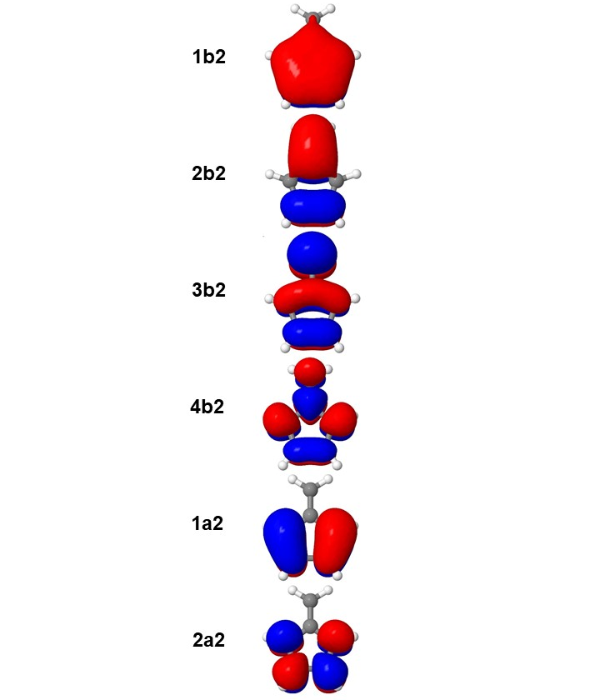
Figure 1: Optimized active orbitals for the S₀ optimized with SA2-CASSCF(6,6)/6-31G.

Directories on CCR:
 | SA2-CASSCF(6,6)/6-31G
S₀ opt | /user/ub2037/fulvene/S0-CAS
S₁ opt | /user/ub2037/fulvene/S1-CAS
MXS | /user/ub2037/fulvene/MXS-CAS/mxs_opt
S₀ opt | /user/ub2037/fulvene/S0-CI
S₁ opt | /user/ub2037/fulvene/S1-CI
MXS

