Work plan:
Fulvene calculations:

Task 1
Determine the active space: full valence CAS in the π space
Orbital occupation for scf calculation:

System: Fulvene Point Group: c2v
N. Electrons: 42 Multiplicity: 1
Level: SCF/6-31G
 |  | IRREP
 |  | a₁ | b₁ | b₂ | a₂
SCF | DOCC | 11 | 7 | 2 | 1
 | OPSH | 0 | 0 | 0 | 0

Task 2:
Perform a closed shell scf calculation (see Appendix for Cartesian geometry); analyze the π orbitals and add the lowest three virtual π orbitals to the active space. What is the resulting CAS orbital scheme?

MCSCF | DOCC | ?? | ?? | ?? | ??
 | RAS | 0 | 0 | 0 | 0
 | CAS | ?? | ?? | ?? | ??
 | AUX | 0 | 0 | 0 | 0

Two states should be calculated: S₀ and S₁. Fill out the table below
States | Multiplicity | N. electrons | Symmetry
1 | ?? | ?? | ?
2 | ?? | ?? | ?
Number of distinct rows (DRTs): ??

Task 3:
Perform a single point state-averaged SA-CASSCF calculations with two states.
What is the excitation energy, the oscillator strength and the orbital excitation scheme of S₁ in comparison to S₀?

State | ∆E (eV) | Configuration | % | Osc. Str.
SA2-CASSCF(6,6)
S₀ |  |  |  | -
S₁

Plot the six π orbitals of the active space.

Task 4
Perform a geometry optimization for the planar S₁ state using the SA2-CASSCF(6,6) method.

 | C-C_{a} | C-C_{b} | C-C_{c} | C-C_{d}
 | SA2-CASSCF(6,6)
S₁

Task 5
Compute the MXS starting from the planar S₁ fulvene structure using the SA2-CASSCF(6,6) method.
 | C-C_{a} | C-C_{b} | C-C_{c} | C-C_{d}
 | SA2-CASSCF(6,6)
MXS

Plot or visualize the two vectors of the branching space and characterize the vibrations.

Task 6
Compute the vertical excitation energy at MRCI(CAS6,6) and MRCI(CAS6,6)+Pople correction using the S₀ MRCI geometry
- Set up the MO occupation table for MRCI
Keep the core orbitals frozen.

MRCI | FC
 | FV
 | DOCC
 | ACT
 | AUX
 | INT

- Copy the SA-CASSCF input from Task 3 into a new directory and make only the MRCI input. Do it for S₀ and S₁ separately as they have different symmetries. Use the MRCI S₀ geometry from the Appendix. Extract the vertical excitation energy and compare it with the SA2-CASSCF result.

MRCI/MRCI+P excitation energies using the MRCI S₀ optimized geometry
State | ∆E (eV) | Configuration | %
S₀
S₁

Task 7
Compute the vertical excitation energy at MRCI(CAS6,6) and MRCI(CAS6,6)+Pople correction using the S₁ MRCI geometry
Copy the inputs from Task 6 into separate directories and use the S₁ MRCI optimized geometry (file geom) given in the Appendix. Replace only the old geom file by the new one and do the calculations.
Important: compute all energies relative to the MRCI ground state energy of the S₀ geometry (Task 6).

MRCI/MRCI+P excitation energies using the MRCI S₀ optimized geometry
State | ∆E (eV) | Configuration | %
S₀
S₁

Solutions

Directories on CCR:
 | SA2-CASSCF(6,6)/6-31G
S₀ opt | /user/ub2037/fulvene/S0-CAS
S₁ opt | /user/ub2037/fulvene/S1-CAS
MXS | /user/ub2037/fulvene/MXS-CAS/mxs_opt
 | MRCI
S₀ opt | /user/ub2037/fulvene/S0-CI
S₁ opt | /user/ub2037/fulvene/S1-CI

Task 2:
CAS orbital scheme
MCSCF | DOCC | 11 | 7 | 0 | 0
 | RAS | 0 | 0 | 0 | 0
 | CAS | 0 | 0 | 4 | 2
 | AUX | 0 | 0 | 0 | 0

States | Multiplicity | N. electrons | Symmetry
1 | 1 | 42 | A₁
2 | 1 | 42 | B₁
Number of distinct rows (DRTs): 2

Task 3:
Vertical excitations at SA2-CASSCF calculation

State | ∆E (eV) | Configuration | % | Osc. Str.
SA2-CASSCF(6,6) – S₀ optimization
S₀ | 0.000 | (1b2)²(2b2)²(3b2)⁰(4b2)⁰  (1a2)²(2a2)⁰ | 75.7 | -
S₁ | 4.080 | (1b2)²(2b2)²(3b2)¹(4b2)⁰  (1a2)¹(2a2)⁰ | 72.0 | 0.0
 |  | (1b2)²(2b2)¹(3b2)²(4b2)⁰  (1a2)¹(2a2)⁰ | 14.8

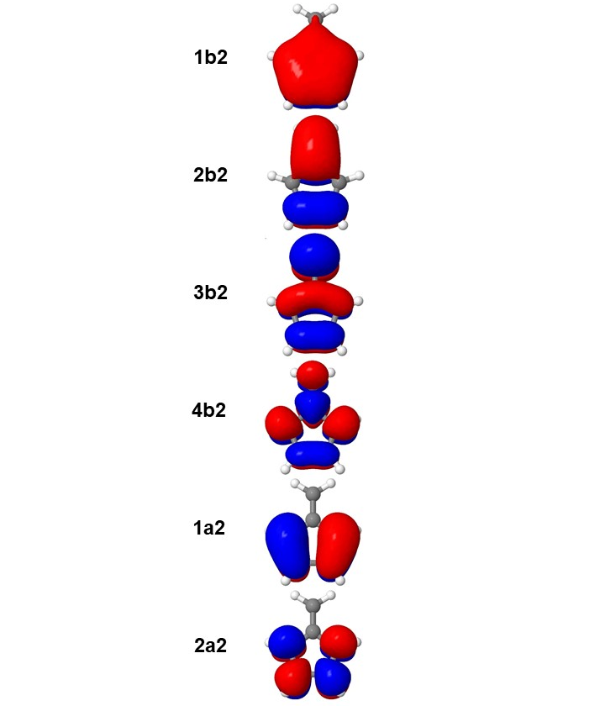
Figure 1: Optimized active orbitals for the S₀ optimized with SA2-CASSCF(6,6)/6-31G.

Task 4

 | C-C_{a} | C-C_{b} | C-C_{c} | C-C_{d}
 | SA2-CASSCF(6,6)
S₀ | 1.352 | 1.479 | 1.360 | 1.482
S₁ | 1.497 | 1.402 | 1.475 | 1.363

Task 5
 | C-C_{a} | C-C_{b} | C-C_{c} | C-C_{d}
 | SA2-CASSCF(6,6)
MXS | 1.583 | 1.373 | 1.538 | 1.321

Task 6
MRCI Occupation Table

MRCI | FC | 4 | 2 | 0 | 0
 | FV | 0 | 0 | 0 | 0
 | DOCC | 7 | 5 | 0 | 0
 | ACT | 0 | 0 | 4 | 2
 | AUX | 0 | 0 | 0 | 0
 | INT | 7 | 5 | 4 | 2

MRCI/MRCI+P excitation energies using the MRCI S₀ optimized geometry
State | ∆E (eV) | Configuration | %
S₀ | 0.000/0.000 | (1b2)²(2b2)²(3b2)⁰(4b2)⁰  (1a2)²(2a2)⁰ | 69.0
S₁ | 3.907/3.779 | (1b2)²(2b2)²(3b2)¹(4b2)⁰  (1a2)¹(2a2)⁰ | 70.1

Task 7
MRCI/MRCI+P excitation energies using the MRCI S₀ optimized geometry
State | ∆E (eV) | Configuration | %
S₀ | 1.268/1.194 | (1b2)²(2b2)²(3b2)⁰(4b2)⁰  (1a2)²(2a2)⁰ | 61.8
 |  | (1b2)²(2b2)¹(3b2)¹(4b2)⁰  (1a2)²(2a2)⁰ | 10.5
S₁ | 2.638/2.600 | (1b2)²(2b2)²(3b2)¹(4b2)⁰  (1a2)¹(2a2)⁰ | 67.3
 |  | (1b2)²(2b2)¹(3b2)²(4b2)⁰  (1a2)¹(2a2)⁰ | 10.8

Appendix
Fulvene geom_unique.xyz file containing the symmetry unique atoms using the SA-CASSCF S₀ geometry
7

C 0.741279 -0.000000 -2.186935
C 1.177643 -0.000000 -0.898511
C 0.000000 0.000000 -0.004256
C -0.000000 -0.000000 1.347324
H 1.349366 -0.000000 -3.067414
H 2.192618 -0.000000 -0.559673
H 0.914227 0.000000 1.909820
Fulvene geom_unique.xyz file containing the symmetry unique atoms using the MR-CI S₀ geometry

7

C 0.746320 0.000000 -2.195217
C 1.187909 0.000000 -0.899709
C 0.000000 -0.000000 -0.001599
C -0.000000 0.000000 1.356855
H 1.358935 0.000000 -3.087441
H 2.214125 0.000000 -0.555979
H 0.922835 -0.000000 1.928229

Fulvene geom file using the MR-CI S₁ geometry

C 6. 1.29873323 0.00000000 -4.32672141 12.00000000
C 6. -1.29873323 -0.00000000 -4.32672141 12.00000000
C 6. 2.14563104 0.00000000 -1.65647062 12.00000000
C 6. -2.14563104 -0.00000000 -1.65647062 12.00000000
C 6. 0.00000000 0.00000000 -0.06736260 12.00000000
C 6. -0.00000000 -0.00000000 2.75695396 12.00000000
H 1. 2.53720115 0.00000000 -5.95135381 1.00782504
H 1. -2.53720115 -0.00000000 -5.95135381 1.00782504
H 1. 4.09852982 0.00000000 -1.04133635 1.00782504
H 1. -4.09852982 -0.00000000 -1.04133635 1.00782504
H 1. 1.75756975 -0.00000000 3.80378726 1.00782504
H 1. -1.75756975 0.00000000 3.80378726 1.00782504

Directories on CCR:
 | SA2-CASSCF(6,6)/6-31G
S₀ opt | /user/ub2037/fulvene/S0-CAS
S₁ opt | /user/ub2037/fulvene/S1-CAS
MXS | /user/ub2037/fulvene/MXS-CAS/mxs_opt
 | MRCI
S₀ opt | /user/ub2037/fulvene/S0-CI
S₁ opt | /user/ub2037/fulvene/S1-CI

